# **Assignment 2.2**

**Question 2**:

Consider below two confusion matrixes produced by two the different supervised models on the same data set. Analyze the performances of the models by computing metrics, accuracy, sensitivity, specificity and F1-score. Which model is better?

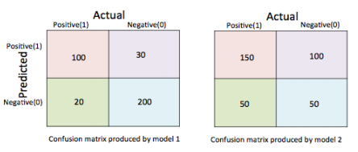

**Metrics for Model 1:**

1. Accuracy = $\frac{TP+TN}{FN+FP+TP+TN}$ = 0.86
2. Recall = $\frac{TP}{TP+FN}$ = 0.83
3. Precision = $\frac{TP}{TP+FP}$ = 0.76
4. F1-Score = $2 \frac{PRE×REC}{PRE+REC}$ = 0.79

**Metrics for Model 2:**

1. Accuracy = $\frac{TP+TN}{FN+FP+TP+TN}$ = 0.57
2. Recall = $\frac{TP}{TP+FN}$ = 0.75
3. Precision = $\frac{TP}{TP+FP}$ = 0.60
4. F1-Score = $2 \frac{PRE×REC}{PRE+REC}$ = 0.67

From the above metrics it is very clear that first model is better than the second one.s